Students Guide – Frequently Asked Questions - Private Sector Rented Accommodation 2021-2022

This booklet is designed for students who are looking for accommodation in the Private Sector. It will provide a brief overview of Private Sector accommodation in Northampton.
More detailed information is available on our website: http://www.northamptonstudentpad.co.uk/Accommodation -
Two important aspects of selecting the right property will be the condition of the property and the manner in which it is managed by the owner or their representatives. To this end, Northampton Student Lets recognises two property accreditation schemes which audit the condition of properties and their management. These are run by Northampton Borough Council (NBC) and Decent and Safe Homes (DASH).

Frequently Asked Questions:

1. What is The Housing List ?
University of Northampton runs housing list online so that all students can access it. The list is live all year round to give students every opportunity to find the right accommodation.
Initially the housing list will contain the details of properties which have been accredited by either Northampton Borough Council or Decent and Safe Homes (DASH). These properties will be identifiable by a logo from the accreditation scheme.
As the accommodation cycle progresses non-registered properties will be added to the housing list. These properties will not have a logo associated with them.

How do I access Studentpad?

The housing list is available at: http://www.northamptonstudentpad.co.uk/Accommodation -
A screen print of the landing page is outlined overleaf. You may wish to start by entering your criteria for the search (e.g. area, number of rooms, price).
You will then be prompted for the password. The password is: Studenthouse21
The list of matching properties will show on the screen.
You also have the option of registering to get frequent updates – click register now on the right hand side.
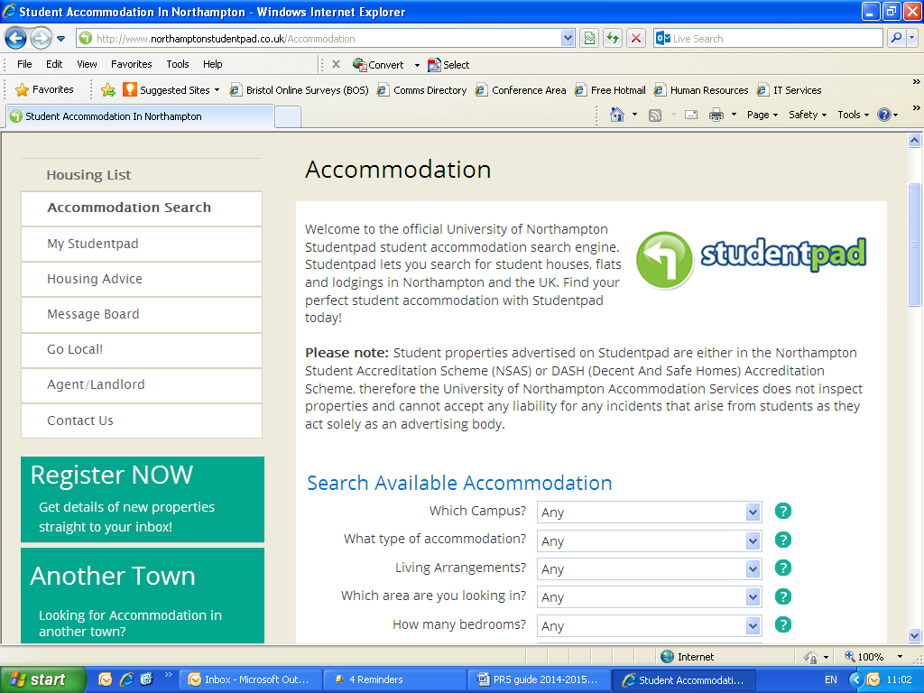

2. What is Student Housing Accreditation Schemes?

Two important aspects of selecting the right property will be the condition of the property and the manner in which it is managed by the owner or their representatives. To this end, Northampton Student Lets recognises two property accreditation schemes which audit the condition of properties and their management.
Decent & Safe Homes (DASH) Accreditation Scheme

DASH Landlord Accreditation is a scheme which recognises and acknowledges private sector landlords with good standards in the condition and management of their properties and their relationship with their tenants.
Accreditations support landlords and tenants in their responsibilities and as such is a significant factor in a strategy of self-regulating for the private rented sector which will contribute to the raising of housing standards.
The scheme allows all landlords to become a member and achieve accreditation. DASH Landlord Accreditation compliments other accreditation initiatives already in operation and works alongside a range of partners in the private rented sector to offer landlords the best experience.

The scheme has been successfully operating since 2008 and is part of DASH Services. DASH Landlord Accreditation was previously known as EMLAS (East Midlands Landlord Accreditation Scheme).

Northampton Student Accreditation Scheme (NSAS)

Northampton Student Lets has worked in partnership with Northampton Borough Council (NBC) and Northampton Landlords Association to create the Northampton Student Accommodation Accreditation Scheme.
This scheme was operated through the Private Sector Housing Solution Team and required the landlord to have each individual property inspected and assessed.
Accreditation for each property lasts for five years. Approximately 250 properties in Northampton have been accredited under this scheme. Unfortunately, NBC have indicated that they can no longer support this scheme. In terms of the housing list, the University will still honour the accreditation on individual properties until they lapse.
By supporting these schemes it is envisaged that students will be encouraged to make informed choices regarding their accommodation. This should enhance the quality of student accommodation in Northampton.
Properties which are registered through either scheme are advertised online through Northampton Student Lets housing list at www.northamptonstudentpad.com and are identified by the attachment of the logo from the respective accreditation scheme.
Towards the end of the accommodation cycle, the housing list will also contain non-registered properties. These properties will have no logo.

What questions to ask Landlord/Landlady?

Gas safety certificate
Please ensure that you check that the property that you are looking at renting has a valid gas safe certificate. All good landlords will have one and it is a legal requirement. You can check details by going to the following website. https://www.gassaferegister.co.uk

Contents Insurance
You will need to insure your personal belongings with in the property where you choose to rent your room. The Building should already be insured by the landlord but they will not insure your personal belongings. Endsleigh insurance offer good rates for students who want to insure their own personal belongings. Visit https://www.endsleigh.co.uk for more information.

Deposit protection schemes
All deposits should be put into a deposits protection scheme as a legal requirement. You can find out more about this by visiting the government website www.tenancydeposit.gov.uk Northampton Student lets currently use my deposits to ensure that all deposit money paid to us is protected.

Housing Hand
For some students it can be a problem getting a UK guarantor. This can be a worry if you are not able to pay the full rent in advance to secure accommodation, and you may still need a guarantor even if you pay your rent in advance. Housing hand can assist with this. Visit their webpage www.housinghand.co.uk

Where to look?
The vast majority of student properties in Northampton lie within a four mile radius of the University. The popular student accommodation areas are:
Far Cotton – Close to Waterside Campus
Kingsthorpe - Close to Park Campus
St James – Close to Waterside campus
Semilong – on bus route
Mounts – on bus route
Kingsley/Poet’s Corner – on bus route
Abington – on bus route
Racecourse – close to Avenue Campus
In many cases these properties are close to the University bus routes. Further information about these routes is available at www.northampton.ac.uk/buses
There are a number of ways in which you may search for private sector accommodation. These include:
Estate Agents/Property management companies - There are a number of companies who may let properties to students. Make sure the Property is checked by the Council for House in Multiple Occupation (HMO). If the property does not hold HMO it is not a safe option.
On-line options and word of mouth - A number of students will secure their accommodation through the recommendation of friends, third parties or the social media. You will need to be mindful of the source of your information when assessing whether it represents a good option for you. Avoid Gumtree, Sparerooms as these properties will not hold HMO certification.

What to look for?
There will be a number of factors which could affect your choice of property. You may wish to consider some of the following:
Rent - How much? For how long? What does it include?
Quality of the accommodation - Is the accommodation in a good condition? Does it hold HMO approval?
Contractual obligations - Are you happy with the terms and conditions outlined in the contract/tenancy agreement?
Location - Are you happy with the location? Where is the nearest bus route? How easy is it to access the University or shops; what is the neighbourhood like?
Flatmates - Who are you sharing the property with? Are they students? If not it might affect the Council Tax status of the property.

Will I have to sign a contract or tenancy agreement?
Yes, most landlords will ask you to sign a contract or tenancy agreement. This agreement should outline your rights and responsibilities whilst you are renting. Any agreement may confer additional rights, but cannot take away any statutory rights which the law gives you.
A contract/tenancy agreement should contain some basic information including: The name of the residents;
The name and address of the landlord/letting agent;
The address of the property being let;
The level of rent (detailing what this may cover e.g. utility bills; council tax; water rates etc.);
The period of the letting.

What is a joint tenancy?
A few landlords may ask you to sign a joint tenancy. This is an agreement between a group of people where you have exactly the same rights and obligations as each other. You are all equally responsible for the agreement.
Therefore if one person does not honour the agreement, for example not paying rent or causing damage to the property, then the landlord can expect the other residents to cover it.

How much rent will I be expected to pay?
The table overleaf gives average costs in the private sector for 2019/2020. Please note individual tenancies will vary.

2020/2021 | Weekly cost (per person) | Total cost (per person)
Anticipated approx. Average rent for a non-en-suite room | £110 | £4,620(42 weeks)
Approximate average weekly utility bills (water, gas, electric) | £35 | £1,470(42 weeks)
Approximate average cost of one journey on public transport to University | £20 (assuming 10 journeys @ £2 per week) | £720 (assuming ten journeys per week for 36 weeks)
Retainer* for the summer, (assuming a charge of 75% rent) | Please check with Landlord | Please check with Landlord
* retainers are not normally applicable if you are securing the property at the end of the summer vacation

How much damage deposit will I be expected to pay?
Landlords will require a refundable damage deposit. This is to cover any damage, beyond normal wear and tear, which may be outstanding at the end of the residency. The average cost is between £300-350 per person. Deposits must be protected by a tenancy deposit protection scheme.
Tenancy Deposit Solutions Ltd (TDSL) – 0870 707 1707 http://www.mydeposits.co.uk
Deposit Protection Service (DPS) – 0871 703 0552 http://www.depositprotection.com
The Tenancy Deposit Scheme (TDS) – 0845 226 7837 http://www.thedisputeservice.co.uk

Will I be able to access the internet?
The majority of private sector houses do not include internet within the rent. This is something you may have to set up separately in conjunction with the other tenants

Will I have a cleaner?
The majority of private sector houses do not include a cleaning service. Please check with your landlord as there may be additional charges to pay for this service to be arranged.

Who pays the bills?
Some landlords will include bills (water, gas electric) in the rent. Details of this should be outlined in your contract or tenancy agreement. If bills are not included you will need to set up payment with each provider and also provide meter readings. Split the bills provide all utilities for one single payment made monthly.

Moving in
There are a number of things which you may wish to do when you first move into a property. These could include:
Ensuring you have the contact details of the landlord/letting agents whom you may need to contact regarding the letting or in an emergency;
Many landlords will now use on-line payment services, however if you are making payment by cash or cheque, ensure that you obtain a receipt outlining what it covers;
Ensuring that you have a copy of your contract/tenancy agreement;
Check with the landlord/letting agent as to how they wish to receive your Council Tax exemption certificate. You will receive a copy of this document at your enrolment. The landlord will require this document to ensure that the property is rated exempt from council tax;
Take all meter readings for the utilities and services for which you are responsible. If in doubt, take them anyway!
You may like to consider taking a photograph of the condition of the property for your records (in case there is a disagreement at the end of your residency);
Familiarise yourself with any appliances, heating controls and stop cock. If you are unsure ask the landlord/letting agent;
Ensure that your possessions are covered by personal possessions insurance;
Introduce yourself to the neighbours (after all you will be living next to one another for up to nine months).
Ensure that you have registered with a local GP.

Can I move rooms if I am unhappy?
The possibility of room transfers within the private sector is limited to the Landlord’s portfolio of properties and availability. Larger landlords may transfer students between houses to help the groups gel – make sure you agree to the room/location/condition before transferring your belongings!

Glossary of Terms
Name | Description
Agent | Someone who acts on behalf of the landlord. Their duties include collecting rent, arranging viewings, and attending to minor repairs. If an agent is in place, clarify the limits of their authority i.e. can they authorise major repairs.
Contract | A legal agreement between two parties usually in a written form, providing some clarification of your rights and responsibilities. Usually Assured Shorthold Tenancy.
Contents Insurance | We recommend all students take out insurance on their personal possessions with a reputable insurance company:  http://www.endsleigh.co.uk/
Council Tax exemption certificate | A form that all full-time students will receive at enrolment. If a property is inhabited solely by full time students then it should be exempt from council tax. Students will need to provide their exemption certificate to the landlord so that they can demonstrate their student status for council tax purposes.
Damage Deposit | A sum of money retained by a landlord against any damage that may occur during the residency. Depending upon agreement, this can cover unpaid bills.
DASH (Decent & Safe Homes) | DASH Landlord Accreditation Scheme – focuses on landlord management and risk assessment of properties. An acceptable alternative to NSAS (below)
NSAS | Northampton Student Accreditation Scheme. Accreditation means the property will be in good condition and the tenancy will be managed to a good standard.

Name | Description
Environmental Health Office (EHO) | A council department which enforces minimum standards in private sector accommodation.
Guarantor | A person who agrees to cover any outstanding liability of a tenant (e.g. rent, damage, bills etc.)
Interlinked fire alarm | A fire detection system, where each sensor and sounder are linked to one another. This enables the efficient notification of activation throughout the property.
Inventory | A list of items contained within the property. Usually completed by landlord and tenant at the beginning of the residency as a benchmark to access standards at the conclusion of the tenancy.
Joint and several liability | A contract where all tenants are bound together. In such circumstances, a tenant could be liable for the outstanding bills/rent of another tenant.
Rent | The money paid by a resident to use the property. This is usually exclusive of utility bills, although a small number of landlords will offer inclusive rents. Ensure that you know which bills are included/excluded in the rent e.g. electricity, gas, water bills etc.
Retainer | Usually landlords will charge a retainer during the summer vacation; in return you should be able to store your possessions in the property. This can be as little as one month retainer and the remaining at full rent please read your contract carefully.

Who We Are:
Private Sector Housing, at University of Northampton is here to help you find safe, secure and affordable accommodation.

Useful Contacts:

Accommodation Team – Help desk – 01604 892482

Madie Patel
Tel: 01604 892434 or 07793529600
Email: madie.patel@northampton.ac.uk
Student Information Desk/Accommodation Helpdesk
01604 892833

Shelter
Tel: 0808 800 4444
Web: http://england.shelter.org.uk

Citizen’s Advice Bureau (Northampton)
Tel: 0844 855 2122
Web: www.mypropertyguide.co.uk
http://www.citizensadvice.org.uk

Northampton General Hospital Accommodation
Tel: 01604 545455

Decent and Safe Homes (DASH)
Web: http://www.dashservices.org.uk/Accreditation

